Report on fall rotation with Dr. Kopell

**Introduction**

Medical professionals administer general anesthetics regularly to patients to render them unconscious during surgery and other medical procedures. Despite the widespread use of anesthetics, a detailed explanation of how this category of drug functions eludes researchers. Quantitative measurements of cortical activity, such as local field potential (LFP) recordings, provide insight into brain activity as the patient transitions from being awake to unconscious. The frequency of oscillations captured by the LFP decrease from beta oscillations in the awake state to delta oscillations, called slow wave oscillations (SWO), in the unconscious state. Slow wave oscillations have two states: an “up-state” where neurons are firing, and a “down-state” where neurons are silent. This shift from beta oscillations to SWO corresponds directly to the amount of anesthesia administered.

The mechanisms responsible for SWO and loss of consciousness remain unknown, and different anesthetics vary in hypothesized methods of causing unconsciousness. <add in specific mechanisms> Though there may be different actions at the cellular level by different anesthetics, they result in the same loss of consciousness. Therefore, a low-level mechanism underlying this collective effect likely exists. Some overlapping changes in brain function include a decreased cerebral metabolic rate and decreased input from the brainstem. Previously, it has been shown that this decrease in metabolic rate is sufficient to drive the brain from beta oscillations to SWO (Cunningham 2006) and even burst suppression (Ching 2012), a brain state with down-states longer and oscillations slower than slow wave oscillations. This provides evidence that modulation of the cerebral metabolic rate could drive the unconscious state. More evidence is needed to support the claim that modulated input from the brainstem is the root director of the decrease brain activity that generates SWO.

To identify if changes in input from the brainstem alone causes SWO, we construct a biophysical model of neural activity and simulate the brain under anesthesia. The model we propose is Hodgkin-Huxley based and captures altered metabolic rate through the addition of a potassium-ATP channel adapted from Ching’s work. Our model has an additional slow potassium current called the M-current. First, we show that like previous models, it can simulate burst-suppression and SWO by reducing the metabolic rate. Then, we show that a reduction in sub-cortical input alone takes the brain from an awake to an anesthetized state. This provides novel evidence for the hypothesis that the loss of consciousness observed under all anesthetics is due to reduced input from the brainstem.

<discuss more of what’s known of large scale brain activity (Lewis 2012, Hutt 2018)>

**Methods**

The objective of constructing a mathematical model of network activity is to investigate potential mechanisms underlying the loss of consciousness under general anesthesia. We constructed a model of with Hodgkin-Huxley type neurons. It consisted of two cell types: pyramidal cells and fast-spiking interneurons. Each neuron type includes a sodium current, potassium current, leak current, and applied current. Pyramidal neurons have additional of KATP and M-currents. The KATP current modulates the excitability of the network as a function of ATP concentration, which fluctuates with the level of brain activity. The M-current is a slow potassium current, which acts as an inhibitory current. The voltage of each cell is determined by the summation of these ionic currents, synaptic currents, and applied current assumed to be from the brainstem. The cells are modeled as follows:

$$c_{m} \dot{V}=-∑I_{syn}-∑I_{ion}+I_{app}$$

Where $I_{ion}$ are the ionic currents described above, and $I_{app}$ is the applied current representing all of the cortical and subcortical inputs that are not accounted for in I_ion and I_syn. To simulate a reduction of input from the subcortical brainstem, I_app will be reduced.

The potassium-ATP current, $I_{K_{ATP}}$, captures the effect of ATP concentration on brain activity. This is a component of $I_{ion}$ in the above equation and is defined by

$$I_{K_{ATP}}=g_{K_{ATP}}z(V-E_{K})$$

Here, $g_{K_{ATP}}$ is the conductance of the potassium-ATP channel, z is the gating variable, V is the membrane potential, and $E_{K}$ is the equilibrium potential of potassium. The gating variable, defined as $z=(1+10{\left[ATP\right])}^{-1}$, is dependent on the concentration of ATP inside the cell (?) , [ATP]. The concentration of ATP inside the cell is strongly linked with the extracellular concentration of sodium, [Na], due to the function of the sodium ATP pump. The equations for the change of [ATP] and [Na] over time are modeled as

$$\left[AT\dot{P}\right]=J_{ATP}\left({\left[ATP\right]}_{max}-\left[ATP\right]\right)-K_{m}{\left[Na\right]}^{3}[ATP]$$

$$\left[N\dot{a}\right]=FI_{Na}-3K_{m}{\left[Na\right]}^{3}\left[ATP\right]$$

F and Km are kinesthetic constants that govern the Na-ATP pump dynamics. They are on an order of seconds which makes this model a candidate for slow wave oscillations. J_ATP is the production rate of ATP which is directly related to cerebral metabolic rate. This parameter will be modulated to demonstrate how reduced metabolic rate could cause unconsciousness.

The M-current is a slow non-inactivating potassium current modeled as:

$$I_{M}=g_{M}M(V-E_{M})$$

G_M is the conductance of the M channel, M is the gating variable, and E_M is the equilibrium potential. Activation of the M-current increases the interspike-inteval period by causing hyperpolarization when the concentration of potassium increases.

Our network contains synaptic currents that allow each neuron to be excited by others in the network. The connections of our ten pyramidal cells and four FS cells are all-to-all. The pyramidal cells are excitatory and activate AMPA currents on connecting cells. The FS cells are inhibitory and activate GABA currents on connecting cells. These synaptic currents are modeled as:

$$I_{syn}=\overline{g}s(V_{pre})(V-E_{ion})$$

The AMPA and GABA channels open only when the presynaptic neuron is active, and thus it is gated by $V_{pre}$, the membrane potential of the presynaptic neuron. The maximal conductance is represented by $\overline{g}$, s is the gating variable, and V is the membrane potential of the post-synaptic cell.

We aim to simulate LFP recordings seen in a clinical setting. We use the sum of all of the AMPA currents in the pyramidal cell population to model the LFP.

$$LFP=\sum_{i=1}^{10}{I_{AMPA}}$$

The sum is taken over the total number of pyramidal cells in the network. $I_{AMPA}$ is defined in the previous section.

**Results**

**Simulation of an awake state**

First, we simulate the awake brain. These results can be seen in Figure 2. The network spikes at a high frequency similar to that observed of patients that are awake and attentive. Thus, tonic spiking occurs when $J_{ATP}$ and $I_{app}$ are at their original amounts. Though ATP and Na fluctuate, they do not leave the range required for activity in the network, and thus there are no down states.

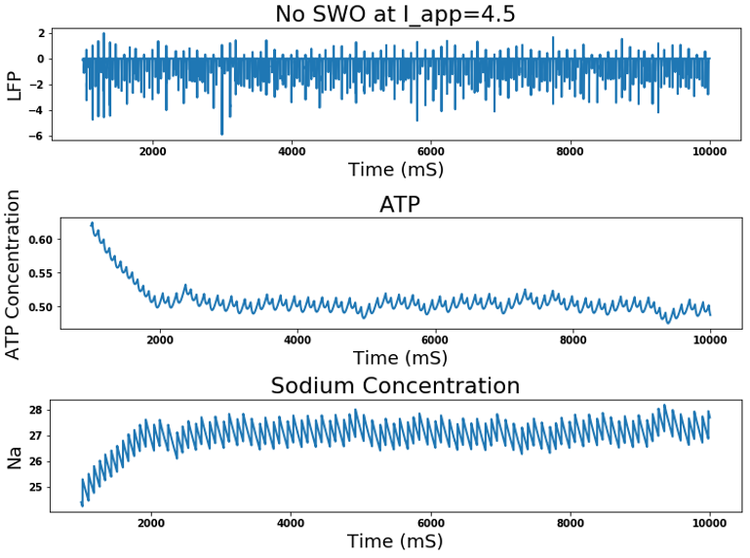

Figure 2: Tonic spiking occurs when $I_{app}$ and $J_{ATP}$ are at their original levels. The top graph represents the simulated LFP, the middle is the concentration of ATP, and the bottom is the concentration of sodium.

**Decreasing J_ATP can cause slow wave oscillations**

We replicated ShiNung’s results with our novel model and showed that a reduction in $J_{ATP}$ causes burst-suppression. The results can be seen in Figure 3. LFP oscillates at a slow delta frequency (.02 Hz) with the ATP and sodium concentrations. When ATP concentration is low the K-ATP channel is open, and K rushes out of the cell causing hyperpolarization. Thus, the cells in the network are kept below threshold for action potentials to fire, and there is no network activity. As ATP increases due to increasing extracellular sodium concentration from lack of action potentials being fired and action from the Na-ATP pump, the K-ATP channels close. This causes depolarization and action-potentials to be fired. The extracellular sodium concentration goes down when the cells fire, due to sodium rushing into the cells during action potentials. Thus, the ATP concentration decreases again and the network is silenced. This cycle repeats causing oscillatory quasiperiodic suppression of activity.

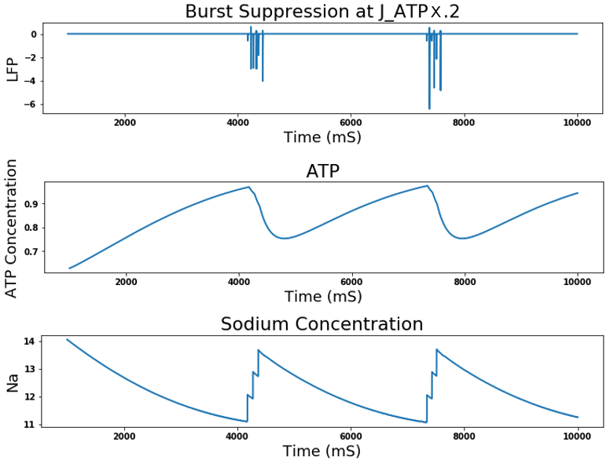

Figure 3: Decreasing $J_{ATP}$ causes burst suppression. The top graph represents the simulated LFP. Quasiperiodic down states appear in the LFP, with short periods of bursts. The middle graph is the ATP concentration, and the bottom is the sodium concentration. Both concentrations fluctuate at the same frequency observed in the LFP.

Next, we demonstrated that this decreased metabolic rate can also cause SWO in our model. This can be seen in Figure 4, where the network exhibits SWO at a slightly increased $J_{ATP}$ value from Figure 2. There appears to be a similar relationship between ATP and Na concentrations and the oscillatory activity in the LFP as observed during the burst suppression state. This demonstrates the correlation between metabolism rate and oscillatory frequency. These simulations confirm that this model can produce both SWO and burst suppression given the same manipulation of parameters as previous models.

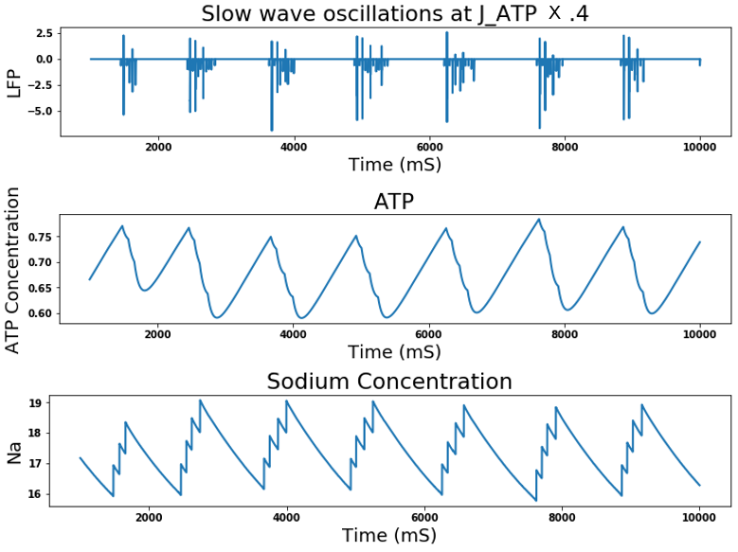

Figure 4: A smaller reduction in $J_{ATP}$ causes slow wave oscillations. The top graph represents the simulated LFP, the middle is the concentration of ATP, and the bottom is the concentration of sodium.

**Decreasing only $I_{app}$ causes slow wave oscillations**

By reducing $I_{app}$, similar results are seen to that of reducing $J_{ATP}$. SWO form when $I_{app}$ is reduced to 75% of its value that simulates an awake state. These results can be seen in Figure 5. The relationship between network activity, ATP, and Na seem to be the same as those observed in Figures 3 and 4. As ATP increases in concentration, the network is excited and spiking. Then, the sodium concentration increases which depolarizes the cell and causes periods of quiescence. Thus, the model can simulate the transition from an awake state to an unconscious state given only a reduction of $I_{app}$.

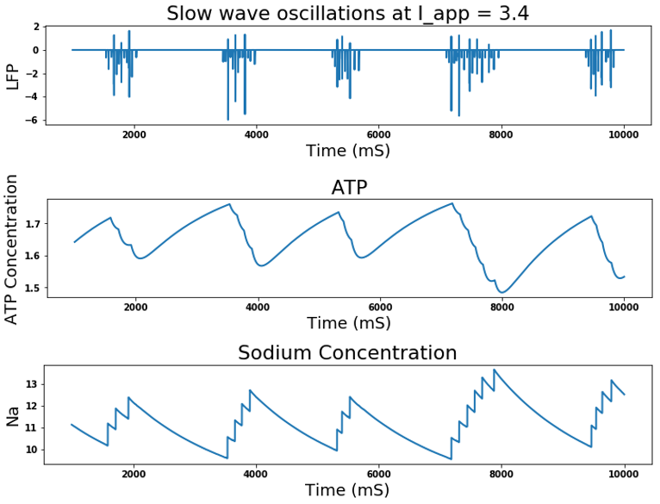

Figure 5: A reduction in just $I_{app}$ causes slow wave oscillations. The top graph represents the simulated LFP, the middle is the concentration of ATP, and the bottom is the concentration of sodium.

**Slow waves caused by a decrease in I_app need the M-current with GABA potentiation**

When $τ_{GABA}$ is set to a value equivalent to that which would be observed under a dose of propofol, the M-current is necessary for the model to produce slow wave oscillations. When the M-current is removed, the interspike interval of individual spikes increase as I_app decreases, but slow wave oscillations characterized by periods of high frequency activity alternating with periods of down-states do not form.

**Slow waves are present without GABA potentiation without the M-current**

When $τ_{GABA}$ is increased to a value that is typical of normal brain function, slow wave oscillations are still caused by decreasing I_app. However, in order for slow wave oscillations to occur, it is necessary to remove the M-current.

**Discussion**

Previous studies demonstrate a link between a decreased metabolic rate on the brain and a reduction of brain activity, but it remains unknown whether this is the case for the decreased activity observed under anesthesia.. Our experiments indeed show a correlation between oscillation frequency and metabolic rate. As value of $J_{ATP}$ is decreased, our network exhibits longer down-states and periods of activity occur less often. Though the reduction of $J_{ATP}$ is sufficient to cause SWO as observed under anesthesia, it is not clear if $J_{ATP}$ is reduced under all anesthetics. Though decreased metabolism rate is a valid model for slow wave oscillations in burst suppression, more experiments need to be done to determine whether there is a decrease in metabolism rate caused by anesthesia. Therefore, we cannot conclude that it is the unifying mechanism which causes the loss of consciousness under all anesthetics.

Our simulations demonstrated that though a reduction in metabolic rate may be sufficient to cause SWO, it is not necessary. We produced SWO by reducing only the applied input to our model. This represents all of the input which is not explicitly modeled and includes input from the brainstem. Reduced input from the brainstem has been observed under all types of general anesthesia. Our simulations of SWO given a reduction in $I_{app}$ provides novel evidence that a reduction of brainstem input initiates SWO and take the brain from an awake to an unconscious state. <need to address why we think its reduction from brainstem and not other components captured by I_app>

As the dose of propofol is decrease with the M-current, our model no longer causes slow wave oscillations. Only when the M-current is removed do we see slow wave oscillations appear once again when I_app is decreased. In these slow wave oscillations we see a decrease in inter-spike interval which is expected as tau_GABA returns to normal levels.

The slow wave oscillations driven by the reduction of $I_{app}$ require that the model includes the M-current. We are still working to understand why it requires this current, and how it is interacting the the K-ATP current to produce SWO. Therefore, one restraint of this model is that some sort of inhibitory current is needed. This is similar to previous models simulating slow wave oscillations which include a persistent sodium current which acts as an inhibitory current.

Notes:

1. Do I include non-SWO figures like need for m-current with propofol and need for m-current without propofol?
2. Need to slowly increase gaba?
3. Compare I_app required for both?

Sources

Ching S, Purdon PL, Vijayan S, Kopell NJ, Brown EB. (2012) A neurophysiological-metabolic model for burst suppression. *Proc Natl Acad Sci USA* 109-3095-3100

Cunningham MO, Pervouchine DD, Racca C, Kopell NJ, Davies CH, Jones RSG, Traub RD, Whittington MA. (2006) Neuronal metabolism governs cortical network response state. Proc Natl Acad Sci USA 103:5597-5601.